BEN BOUIE MIXED OPEN 2024
RESULTS

1st Place – Fiona Chalmers (Helenburgh GC)/Iain Baird (Blairgowrie GC) – 43pts
2nd Place – Lorraine Daw/Neil Munro (Blairmore & Strone GC) – 40pts BIH
3rd Place – Shona Bulloch/Sandy Bulloch (Helensburgh GC) – 40pts

Ladies Longest Drive – Shirley Monaghan (Helensburgh GC)
Gents Longest Drive – Gordon Mickel (Helensburgh GC)
Ladies Nearest the Pin - Babs Robertson (Helensburgh GC) – 3.38m
Gents Nearest the Pin – Gordon Nicol (Stirling GC) – 1.13m

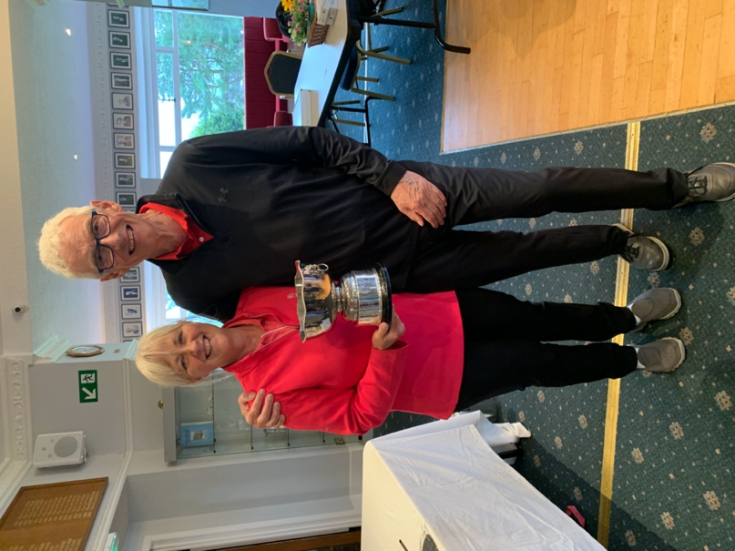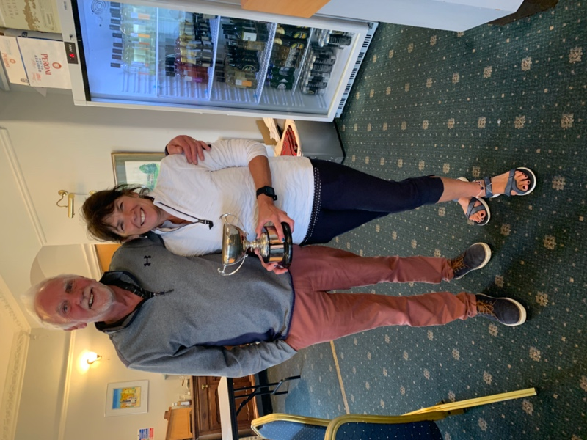

Fiona Chalmers/Iain Baird Shona & Sandy Bulloch, best Helensburgh
Winners of Ben Bouie Trophy – 43pts team and winners of the Ardmore Trophy –
40pts

