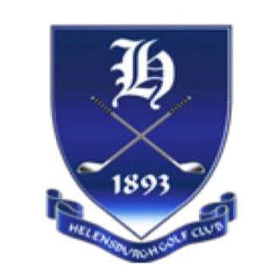
HELENSBURGH GOLF CLUB
LADIES OPEN TRI-AM
10TH JULY 2024

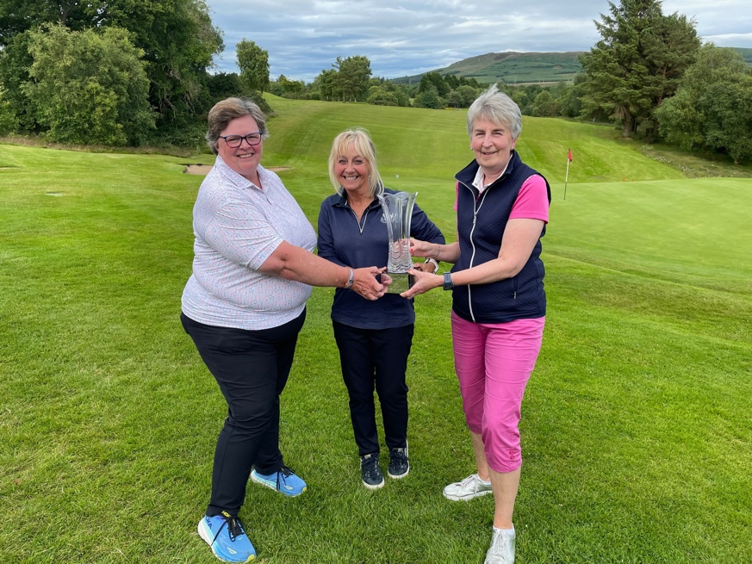

PRIZES |  | NAME/CLUB
1st HANDICAP  90 stableford pts | ARDARDAN VASE  + £80pp | E. Smith (Paisley GC)  L. Forsyth (Paisley GC)  P. Buttar (Paisley GC)
2nd HANDICAP  86 stableford pts | £60pp | R. Sharp (Dougalston GC)  A. Brown (Dougalston GC)  A. Culpan (Hilton Park GC)
3rd HANDICAP  85 stableford pts | Milne Centenary Cup  (Best Helensburgh Team)  + £40pp | A. Riding (Helensburgh GC)  L. Inglis (Helensburgh GC)  F. Thomson (Helensburgh GC)
Nearest pin @ 9th  Bronze | £10 | Anne Burns (Dougalston GC)
Nearest pin @ 16th  Silver | £10 | Jackie Lightfoot (Helensburgh GC)
Longest Drive @ 7th  Bronze | £10 | Rachel Leach (Wishaw GC)
Longest Drive @ 7th  Silver | £10 | Carolyn Stait (Burnham & Berrow GC)
2s | Rona Marshall @ 3rd, E. Smith @ 3rd, M. MacLeod @ 16th

